

**American International University- Bangladesh**

**CSC 3215: Web Technologies**

**CO2 and CO4 Evaluation**

**Finished Project Report**

**Spring/Summer/Fall 2020-2021**

**Project Title: Web based Ticket System (eTickets)**

**Section: F**

|  |  |
| --- | --- |
| Student Name | Student Id |
| Md. Shahoriar Alif Utsho | **18-38055-2** |
| Diya Rahman | **18-38282-2** |
| Sabah Raad | **18-38242-2** |

**Project Description:**

In our project, Admin, Operator and Customer can log in from the same login page. One customer can log in after completing the Registration to book ticket. A customer can search for the bus just by entering the Source, Destination and Date of Journey. Customer can select their desirable seats from the available seats. Customer can also see the ticket list of their own.

Every bus operator will be registered by the admin. After registration, operator can add their bus by entering Coach id, Source, Destination and Journey fare. Every coach id will be unique. Operator can monitor all of their bus, can edit and delete also. Operator can check the total Revenue. Revenue will be counted from all of the booked tickets of their coach. Operator can also check the reservation of a single coach with a selected date with the ticket list.

Admin can add the bus operator, edit and delete them. Also, can monitor the total bus and total revenue of all the operator. Admin can check the reservation of all coach from all operator with the ticket list.

**Project Folder Structure:**

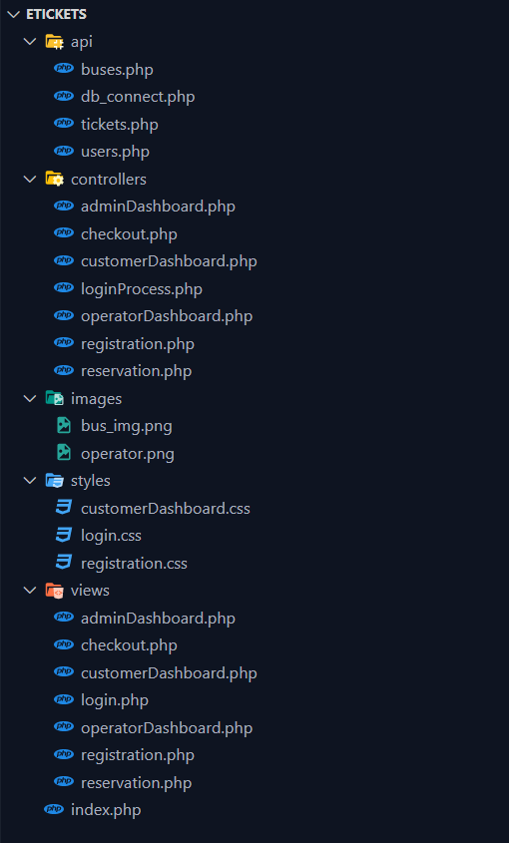

**Core Modules of the Project:**

***customerDashboard.php***

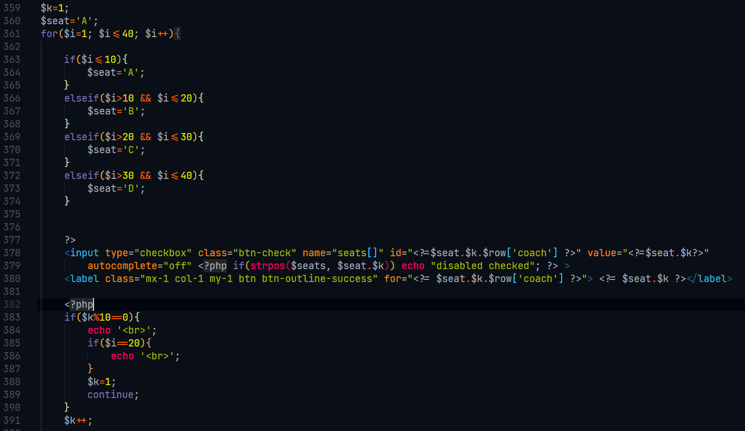

***registration.php***

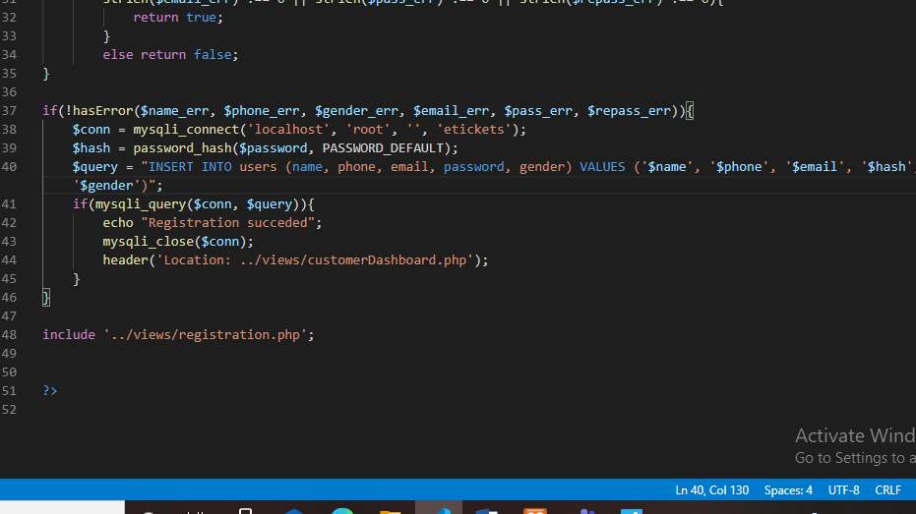

***operatorDashboard.php***

